Ideas Clinic Robotic Arm Architecture

Figure 1: Labelled Kinematic Diagram

# Electrical Configuration

1. Plug the twisted red/black wire into a 12V power supply block.
2. The micro-stepping motors wire to the motor controllers according to the robotic arm wiring document.
3. The black USB should connect to your laptop for flashing code.
4. The serial wires (clear cable with multiple colors inside) were once used to connect to the groov rio PLC. The specific functionality of this is poorly documented, more research will be required to get this working again.
5. For the limit switches, refer to figure 2. The pink squares correspond to the pins on the xnucleo motor controller boards. The innermost blue text are the labels for the xnucleo board pins. You can configure which pin will read which limit switch in the code using the following definition. 

For PA1, the GPIO pin is one, for PB3, the GPIO pin is 3, etc. Later you must configure these GPIO pins using the following format.

You can set different parameters (check the HAL documentation for more information), but make sure that the letter (A,B,C) corresponds the the letter bank of the pin you’re using. For PB10 for example, each GPIOA above must be replaced with GPIOB.

Each limit switch has wires running to the board. You can check which wire corresponds to which limit switch by the colored tape on the wires.

Figure : Xnucleo pinout

There should be two wires left to connect, a black wire and a red wire, as held in figure 3. Connect the red wire to +5V according to figure 2, and the black wire to GND. This should enable the use of the limit switches. Use a DMM to test whether the limit switches are active high or low.

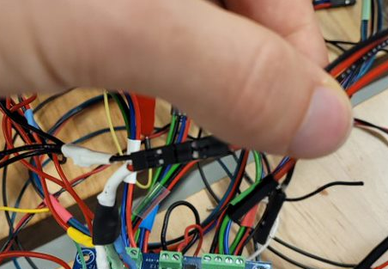

Figure : Remaining limit switch wires

# Potential Wiring Issues

* If a motor is buzzing, but not moving a joint when sent a command to do so, it means that the four wires are connected to the motor controller in the wrong order.
* If controlling a motor connected to port A on one motor controller in the daisy chain configuration also controls the motor connected to port A of another controller, it means that the nCS solder bridges are set as the same for these controllers. This can be fixed. Text

  Description automatically generated
* Simply check the nCS bridges on each of the controllers (highlighted in figure 4) If two of the controllers have a solder across the same bridge, simply resolder one controller across a different bridge after breaking the duplicate connection. A picture containing text, circuit, electronics

  Description automatically generated

Figure : nCS bridge

Then configure xnucleoihm02a1.h to reflect these changes.